

IZY FH 3

Installation, Operation & Maintenance Instructions

Please leave this instruction booklet with the end user as it contains important warranty, maintenance and safety information

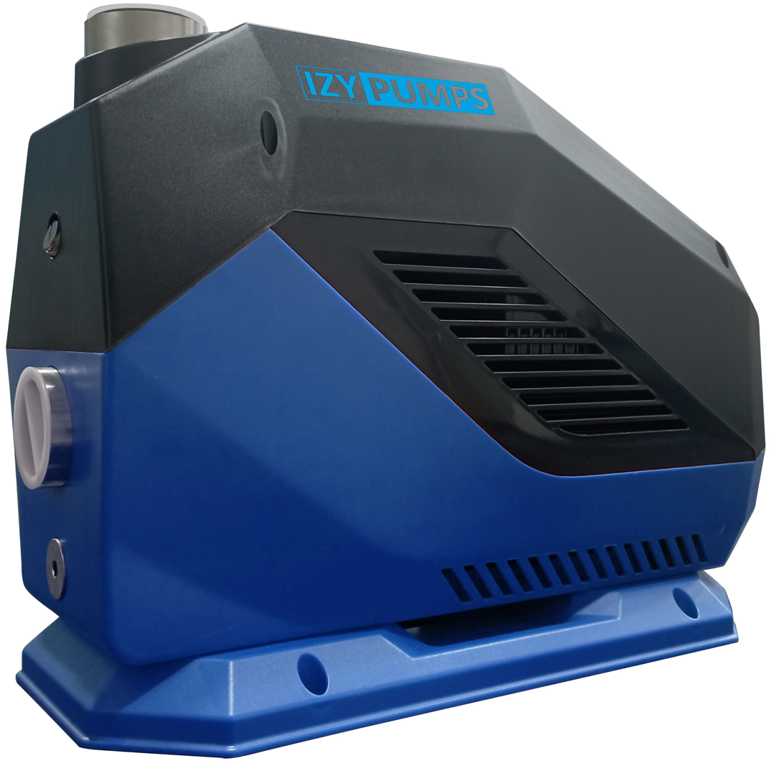

Read this manual carefully before commencing installation.
This manual covers the following products:

IZY FH 3




PRODUCT DESCRIPTION
Electric motor driven centrifugal pump complete with an automatic control system, consisting of pressure transducer pressure vessel and electronic control.

APPLICATION
The IZY FH series is designed for pressure boosting applications in vented stored, cold, clean water systems, where under gravity, no flow is available and can be used in systems where either a positive or negative head exists. Inlet pressures to the pump must not exceed the values given in the technical specifications.

STORAGE
If this product is not to be installed immediately on receipt, ensure that it is stored in a dry, frost and vibration free location in its original packaging.
CONTENTS Page
Checklist 4
Important Facts - read before commencing installation 6
Location – General 7
Location – Cold Water Installation 8
Location – Suction Lift Installation 9
Pump Connections 11
Electrical Installation 12
Commissioning 14
Maintenance 17
Technical Specification 18
Trouble Shooting 20

WARNINGS:
- This pump set must not be used for any other application without the written consent of Reynaert pompen BVBA and in particular, must not be connected directly to the mains water supply.

This appliance can be used by children aged from 8 years and above and persons with reduced physical, sensory or mental capabilities or lack of experience and knowledge if they have been given supervision or instruction concerning use of the appliance in a safe way and understand the hazards involved.
- Children shall not play with the appliance.

Cleaning and user maintenance shall not be made by children without supervision.
- This product should not be used for the supply of water to more than one dwelling (house, apartment, flat).

Maximum head (closed valve) – 55 metres.
- The motor casing can become very hot under normal operating conditions. Care must be taken to ensure it cannot be touched during operation.

The electrical installation must be carried out in accordance with the current national electrical regulations.
- The electrical installation must be installed by a qualified person.

RCD’s/ELCB’s are not recommended for use with variable speed drives/motors. If an RCD is mandatory use type B RCD’s.
- For single phase sets with invertor motors the earth leakage circuit breaker must trip out when an earth fault currents with DC content (pulsating DC) occur.

RCD’s suitable for use with variable speed drives/motors are not suitable for personnel protection.
- Do not touch any electrical components for at least 5 minutes after the unit has stopped to allow any discharge to occur safely.

Before starting work on the electrical supply ensure power supply is isolated.
- DO NOT allow the supply cord to contact hot surfaces, including the motor shell, pump body or pipework. The cord should be safely routed and secured by cable clips.

If the power cord is damaged, it must be replaced by an appropriately qualified person in order to avoid a hazard.
- This appliance must be earthed via the supply cord.

Please read installation details carefully as they are intended to ensure this product provides long, trouble free service. Failure to install the unit in accordance with the installation instructions will lead to invalidation of the warranty.

CHECKLIST
IMPORTANT: With the pump removed from its packaging check for any damage prior to installation. If any damage is found contact Reynaert pompen BVBA within 24 hours of receipt.
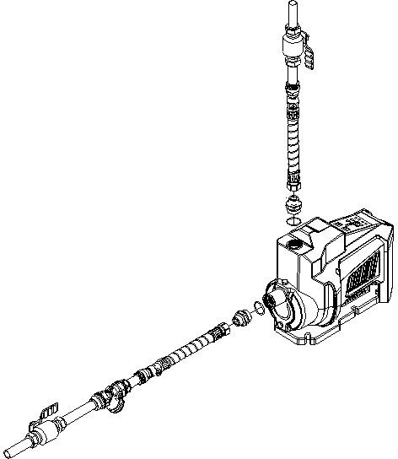
Short 22mm coper pipe tails to connect between isolating valve and flexible pipes.
22mm flexible hose.
These hoses are fitted with G¾ female connector suitable for connection to a G1m to G¾ adaptor or fitting.
B
C
A
D
B
22mm copper inlet pipework (suction)
22mm isolating valve (non- restrictive) and fittings (not supplied) to allow easy pump service.
22mm copper outlet pipework (discharge).
Fig 1.
Typical installation configuration.

ITEM | DESCRIPTION | QTY
A | Pump | 1
B | Hose | 2 | Items B & C not supplied
C | Inlet /outlet connector & gasket | 2
D | In line filter | 1 | Not supplied but recommended.

Note: Item C, if purchased, is supplied loose and will require fitting to the pump inlet/outlet. Tighten to torque 4/5 Nm. Your product may vary slightly from the picture above.

IMPORTANT FACTS: READ BEFORE COMMENCING PUMP INSTALLATION

A Water storage capacity.
- The cold water storage capacity (must be a minimum of 230 litres) and sufficient to meet the flow rates required by the pumped equipment and any other water using fittings and appliances, which may be operated simultaneously.
- Ensure the pump is primed as described in the priming section before starting, damage to the shaft seal will result otherwise. See Section 5 - Commissioning.

B Water temperature
- The water entering the pump must be controlled as follows:
- The minimum allowable water temperature is 4°C.
- The maximum allowable water temperature is 60°C.

C Pipework - General
- Secure pipework: Ensure pipework to and from pump is independently supported & clipped to prevent forces being transferred to inlet and outlet branches of pump.
- Flux: Solder joints must be completed, and flux residues removed prior to pump installation (flux damage will void any warranty).
- Pipework design: Care should be taken in the design of pipework runs to minimize the risk of air locks e.g. use drawn bends rather than 90° bends.
- DO NOT introduce solder flux to flexible hoses, pumps or pump parts manufactured from plastic.
- DO NOT allow contact with oil or cellulose based paints, paint thinners or strippers, acid based descalents or aggressive cleaning agents.
- DO NOT install a non-return valve, or devices which contain non-return valves, in the suction (inlet) pipework to the pump. The pump must be free to vent to the supply tank at all times.
- DO NOT bend the flexible hoses beyond 30°. They must be installed as straight as possible.
- DO NOT connect this pump to the mains water supply.

D Plumbing Installation Regulations
- The plumbing installation must comply with the current water and building regulations.
- The plumbing installation must be installed by a qualified person.

LOCATION - GENERAL
  - Access: For emergencies and maintenance the pump must be easily accessible.
  - Protection: The pump must be located in a dry position, frost free and protected from freezing, particularly when installed in a loft (not recommended). The pump must be protected from the elements.
  - Ventilation: Ensure an adequate air flow to cool the pump. Separate the pump from other appliances that generate heat. An 80mm (3“) air gap must be maintained around the pump.
  - Safety: The motor casing can become very hot under normal operating conditions. Care must be taken to ensure it cannot be touched during operation.
  - Water retention: Site the pump in a location where in the unlikely event of a water leak, any spillage is contained or routed to avoid electrics or areas sensitive to water damage.
  - Static inlet pressure: Before deciding where to locate the unit check to ensure the static inlet head between pump and the bottom of the cold water tank (Ref Fig. 2) does not exceed the max inlet head of 10 metres.
  - Ambient temperature: The pump must be sited in a location where the maximum ambient temperature does not exceed 45°C.
  - Pipework: For optimum performance pipework use 22mm diameter.
  - Fixing: Ensure the pump is adequately secure when installed.

Note: Inlet pipework must always be greater than or equal to the outlet pipework diameter. Pipework should only reduce to 15mm when entering terminal fitting.
When the length of the inlet pipe is more than 10 meters or the height of the inlet pipe is greater than 4 meters, the diameter of the inlet pipe must be larger than the diameter of the outlet.

  - Static outlet pressure: The static outlet head (Fig 2) must also be within the maximum requirement of 12 metres.
  - Noise: Care must be taken when mounting the pump so that noise is not amplified through loose panels or pipework.
  - Direction of flow: Ensure water enters the pump via the inlet on the front of the pump and exit out the top.
  - Isolating valves: Separate system isolating valves (non-restrictive) must be fitted to allow easy pump service.

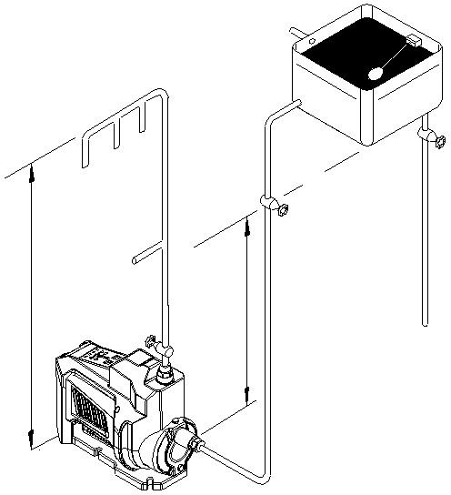LOCATION - COLD WATER INSTALLATION
Static outlet pressure 12m max.
Static inlet pressure 10m max.

Fig 2.
Diagram showing typical cold water installation.

  - The cold water supply: Must be a DEDICATED AIR FREE supply via a tank connector. Do not connect to the mains.

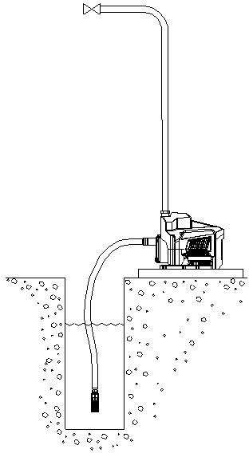Pump Mounted Above Liquid Source (Suction Lift Installation):
Max. suction lift 8m
Max. static outlet pressure 12m

Fig 3.
Diagram showing typical pressure control installation with suction lift.

  - The pumps can be used in a suction lift installation providing the height of lift is within the limits specified in the limits of application section and the liquid to be pumped is cold water.
  - Before deciding where to locate the unit, check to ensure the static outlet head does not exceed the maximum requirements 12 metres (Ref fig 3).
  - A footvalve and strainer may be used, and the suction pipework size must match the pump. In order to prevent solid particles from entering the electric pump, the inlet pipe must be equipped with a filter.
  - Lay the suction piping over the shortest possible distance and ensure there is a constant rise from the liquid source to the pump. Any high spots will cause air pockets to form, reducing system efficiency.

  - Ensure all joints in suction pipework are completely airtight. Failure to comply will result in loss of prime.
  - The intake of the footvalve/strainer should be positioned such that it cannot be blocked with debris or silt that are frequently found in the bottom of sumps and wells.
  - When a footvalve is installed in the suction pipework, it is recommended that suitable pressure relief valve be fitted in the discharge (outlet) pipework from the pump.

PUMP CONNECTIONS
  - Hose to pump: These pumps have G1 threaded connections. If flexible hoses are used, the flexible hose end is made water tight with a sealing washer on assembly, nip tight to 4/5 Nm for water tight seal (do not overtighten).
  - Hose to pipework: Hoses terminating in G1 threaded connections should be sealed with PTFE tape or other suitable sealant.

ELECTRICAL INSTALLATION / EARTHING
  - Regulations: The electrical installation must be carried out in accordance with the current national electrical regulations and installed by a qualified person.
  - RCD’s/ELCB’s are not recommended for use with variable speed drives/motors. If an RCD is mandatory use type B RCD’s.
  - For single phase sets with invertor motors the earth leakage circuit breaker must trip out when an earth fault currents with DC content (pulsating DC) occur.
  - RCD’s suitable for use with variable speed drives/motors are not suitable for personnel protection.
  - Do not touch any electrical components for at least 5 minutes after the unit has stopped to allow any discharge to occur safely.
  - Before starting work on the electrical supply ensure power supply is isolated.
  - DO NOT allow the supply cord to contact hot surfaces, including the motor shell, pump body or pipework. The cord should be safely routed and secured by cable clips.
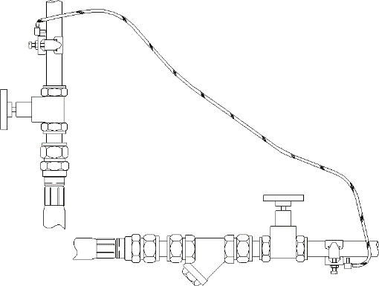
  - Adjacent pipes: Adjacent suction and delivery pipes should be fitted with earthing clamps in accordance with current regulations (ref Fig 4).

Fig 4.
Diagram of earth continuity connections

  - Earthing: This appliance must be earthed via the supply cord.
  - Pipework: Copper or metallic pipework must have supplementary earth bonding where the continuity has been broken by flexible hoses or plastic components (not supplied).
  - Additional earthing: Certain installations may require additional earthing arrangements such as equipotential bonding. Reference should be made to the relevant regulations concerning this subject to ensure compliance.
  - Connections: The pump must be permanently connected to the fixed wiring of the mains supply using the factory fitted supply cord, via a double pole switched fused spur off the ring main and NOT connected to the boiler or the immersion heater circuits.

Wiring of connection unit:
WARNING: This appliance must be earthed.
The wires in the mains lead (supply cord) are coloured in accordance with the following code:
- Green and Yellow: Earth
- Blue: Neutral
- Brown: Live

As the colours of the wires in the mains lead of this appliance may not correspond with the coloured markings identifying the terminals in your connection unit proceed as follows:
- The wire which is coloured green and yellow must be connected to the terminal in the connection unit which is marked with the letter E or by the earth symbol: or coloured green or green and yellow.
- The wire which is coloured blue must be connected to the terminal which is marked with the letter N or coloured black.
- The wire which is coloured brown must be connected to the terminal which is marked with the letter L or coloured red.

  - Fuses: The pump should be fitted with a 5A fuse.

COMMISSIONING / SYSTEM FLUSHING / PRIMING / STARTING
  - System Flushing: The pipework system should be flushed out prior to the pump being connected to ensure any contaminants / chemical residues and foreign bodies are removed from elsewhere in the system.
  - Water Supply: Always ensure that water storage capacity is adequate to meet the demand. Ensure the pump chamber is full of water before starting the pump. Failure to do this could result in seal damage. To ensure dry running does not occur the pump must be primed as described in priming section below. Do not run pump dry. The volume ratio of solid impurities in the medium should not exceed 0.1%, and the particle size should not exceed 0.2mm diameter.

Priming:

Never operate pump with inlet and/or outlet isolating valves in the closed position. Damage will occur!

The pump must be primed (filled with water) before starting. Turn on the service valves and vent/prime pump head.
- Loosen priming plug and allow an even flow of water, this may take a few seconds.
- 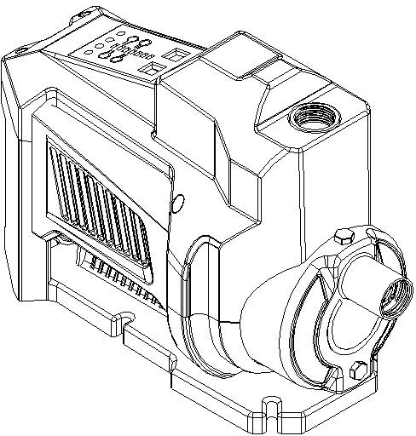Re-seal draining plug, nipping tight. The pump is now ready to start.
Drain plug
Priming plug

Fig 5.
IZY FH 1

Starting:
- Ensure all outlets are closed, turn power supply ‘on’ - pump will start, pressurise the system then stop.
- Open and close all outlets in turn associated with the pump, (including w/c systems) allowing water to flow from each outlet until all air is purged. As each outlet is opened and closed, the pump will start and stop respectively.
- Note: After closing the outlet there will be a small time delay before the pump stops, which is normal.
- Any tap or control valve within the system when opened and closed will now turn the pump on/off. Providing this is the case the system is now operating correctly.
- Carefully check pump and pipework for leaks whilst pump running and stationary before leaving the installation unattended.

For further technical support: Phone the Reynaert pompen BVBA Tech Assist team .
Our staff are trained to help and advise you over the phone.

How to use the control panel:
- Ensure the pump has mains power. The pump will power up 3 seconds after mains power is introduced.
- Press and hold start/stop key for 3 seconds to enter speed mode.
- Select desired pressure using up or down arrows to change the ‘SET PRESSURE’ display to desired pressure.
- Press and hold start/stop key again to stop pump operation.
- Press and hold ‘Reset’ button for 3 seconds to reset pump to default pressure of
3.5 bar.

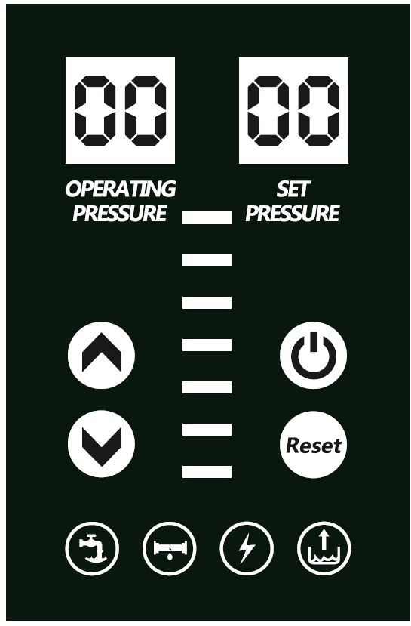
q
b
c
d
Reset button
Pressure decrease button
Start/Stop button
Pressure increase button
SET PRESSURE
display shows the pressure the pump is currently set at.
“OPERATING
PRESSURE” display shows current actual pressure the pump is producing.

Fig 6.
Control panel

Indicator buttons:
- Pump is ‘ON’
- Leakage detected in pipeline: Check where possible for leaks or contact appropriately qualified person.
- Voltage protection: Input voltage has fallen out of specification for pump, contact appropriately qualified person for correction.
- Dry run detected: refer to section 8.11.

MAINTENANCE
  - Disconnect electrical supply before working on the pump.
  - Turn off water supplies to the pump and release pressure by opening water outlets before attempting maintenance.
  - Cleaners, Disinfectants and Descalents: Acid based descalents and aggressive cleaning agents must not come into contact with the pump. The pump must be removed from the system prior to the use of these products. The system should be flushed to remove all chemicals before the pump is reconnected. If in any doubt as to the suitability of the chemical solutions, please contact our TechAssist helpline on www.pompenreynaert.com.
  - When the ambient temperature is lower than 4°C and the pump is not in use, the pump chamber should be drained of water to protect internal components.

TECHNICAL SPECIFICATION
Reynaert pompen BVBA reserve the right to amend the specification in line with its policy of continuous development of its products.
  - Noise: The equivalent continuous A-weighted sound pressure level at a distance of 1 metre from the pump does not 66dB(A).

Physical Enclosure protection IPX4 Length: 391mm
Width: 194mm
Height: - excluding hoses 292mm Weight: 9kg

Pump Model |  | IZY FH 1
General | Warranty | 2 years
Features | Pump type | Centrifugal Multistage
Features | Pump control | Pressure/flow switch
Features | Inlet strainer(s) | Optional
Features | Flexible hoses | Optional
Features | Dry run protection | ✓
Features | Priming vent plug | ✓
Features | Self priming | ✓
Features | Typical noise | 66 dB(A)
Materials | Pump body | Stainless steel
Materials | Impeller | Plastic
Materials | Mechanical seal | EDPM / Carbon / Ceramic
Performance | Maximum head - closed valve | 55 metres
Performance | Performance @ 60 l/min | 20.4 metres
Performance | Performance @ 80 l/min | 10.2 metres
Performance | Maximum flow | 97 l/min
Performance | Maximum static inlet pressure | 10 metres
Performance | Maximum static outlet pressure | 12 metres
Performance | Maximum working pressure* | 650 kPa (6.5 bar)
Performance | Max. ambient air temperature (continuous) | 45°C
Performance | Min / Max water temperature | Min 4°C / Max 60°C
Performance | Max. suction lift* | 4 metres
Connections | Pump connections | G1 F
Motor | Type | Permanent magnet variable frequency
Motor | Duty rating | Continuous (S1)
Electrical | Power supply (Vac/Ph/Hz) | 230 V a.c. / 1 / 50 Hz
Electrical | Power consumption - P1 | 665 Watts
Electrical | Current- full load | 2.9 Amps
Electrical | Fuse rating | 5 Amps
Electrical | Power cable length | 1.5 metres
Phy #sical | Enclosure protection | IPX4
Phy #sical | Length | 391 mm
Phy #sical | Width | 194 mm
Phy #sical | Height - excluding hoses | 292 mm
Phy #sical | Weight - including fittings | 9 Kg

*Note: A suction lift of up to 4 metres can be achieved if a footvalve and strainer is used.

TROUBLE SHOOTING GUIDE

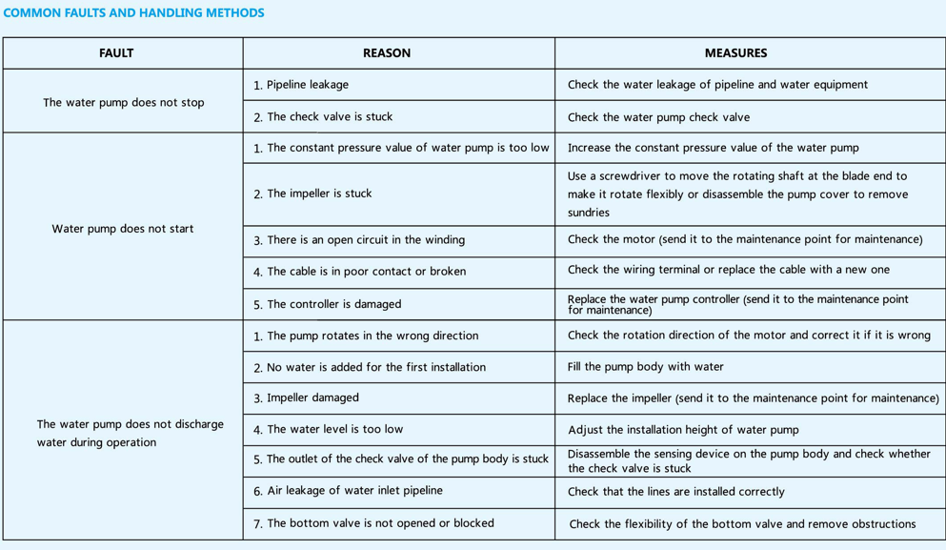
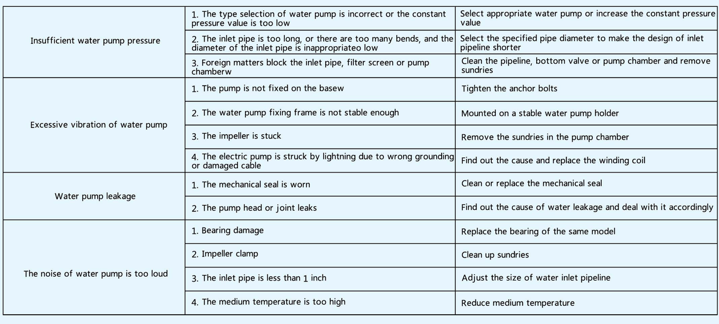

Dry Run Protection:
This pump is fitted with a safety control circuit, which will detect the following fault condition:

Dry running caused by water starvation to the pump.

Should the pump run out of water it will stop as part of a “protective logic sequence”, detailed below.
The fault should be rectified before re-starting the pump. Check that there is sufficient water supply to the pump and also ensure that all terminal fitting outlets are closed.

Protective Logic Sequence:
If water starvation occurs and the power supply to the pump remains uninterrupted, the pump controller will perform the following protective sequence.
    - If the pump detects water starvation, it will stop operation.
    - The pump will remain in the off condition for a period of 5 minutes.
    - The pump will then re-start and if the water starvation condition remains present, the pump will stop operation.
    - The pump will remain in the off condition for a period of 5 minutes.
    - The pump will then re-start and if the water starvation condition remains present, the pump will stop operation.
    - The pump will remain in the off condition for a period of 5 minutes.
    - The pump will then re-start and if the water starvation condition remains present, the pump will stop operation.
    - After three consecutive resets are performed the pump will remain in the off condition for 6 hours then restart.

If the pump fails to operate normally after three attempts, then please consult the TechAssist team on www.pompenreynaert.com.

Environment Protection: Your appliance contains valuable materials which can be recovered or recycled. At the end of the products’ useful life, please leave it at an appropriate local civic waste collection point.

